Feasibility Study on Institute Finder

BACKGROUND

A study was being conducted for a final capstone project. As we were students ourselves we didn’t have to look far to find a problem. As a student coming to Canada we had to face some challenges to find a suitable course. We were very much overwhelmed by the choices of all the courses available at different colleges. We had to go through all of that courses, their content, admission requirement and fees. It would take a lot of time to narrow down on a course. And after all that research on the course we would find out that we did not meet the admission criteria.
In order to solve this problem we came up with a solution that would narrow down the search of the courses according to the user likings. And we though to add more feature on top of that like Download data, print data and deduplication of data.

SUMMARY OF KEY FINDINGS AND PROPOSALS OF THE STUDY

Technical feasibility

The software would be hosted on a college server. The application would be receiving the data from the college database. We would be using two API. GETDATA and SETDATA API which would be used to fill the data into the application from the database. College Admin would be having access to this API and they would be updating the course data.

Operational feasibility

The website would be updated by college staff. College Admin would be responsible to update any of changes made in course or any new course added. Admin would be getting necessary information from professor or respective admission department and according to that data would be updated in the website.

College admin would be responsible to update the course details using GETDATA and SETDATA API. The admin would also be checking for duplication of the data in the website.

Proposal

The Study concluded that, it is important to evaluate the most appropriate and time saving ways of improving the process of finding a course in college. And in order to make the admission research process more easy and convenient, it is required to make a application where its very easy for user to navigate through the website and select a course. With the click of a few button, the user can add so many filter and can narrow his choices for courses in his favorite courses in his choice of city.

Financial viability

Development of this system would be a great financial decision because this will increase the total number of admission and total turnaround time of admission of a student. Colleges would be able to make instant changes made to the course details and that would be instantly reflected in the website.

This would make the selection procedure of the course more easier for the student as the student can set advance filter and select their favorite course. This way the student won’t be confused as they will be able to select their course easily. This would incase increase the income of the college.

Existing Architecture

The current system displays a plethora of courses and bombards with all of the information. Sometimes this information is not necessary for the future student and it confuses them and also it waste their time on searching their required course. It is kind of like finding a needle in a haystack. The user cannot categorize by department, field of study or intake.

New development

A system with advance filter criteria which would be used by the user to se various filters like Field of study, Intake, City, fees range and many more. This would save a lot of time of student to research for the college and would make admission process quicker. The student can also share the course details with their friend via downloading course details or a print of the course data. The college admin can update the changes in the course instantaneously via GETDATA and SETDATA API. The admin will have a tool that would allow to delete the duplicate data from the system.

Use Case Diagram

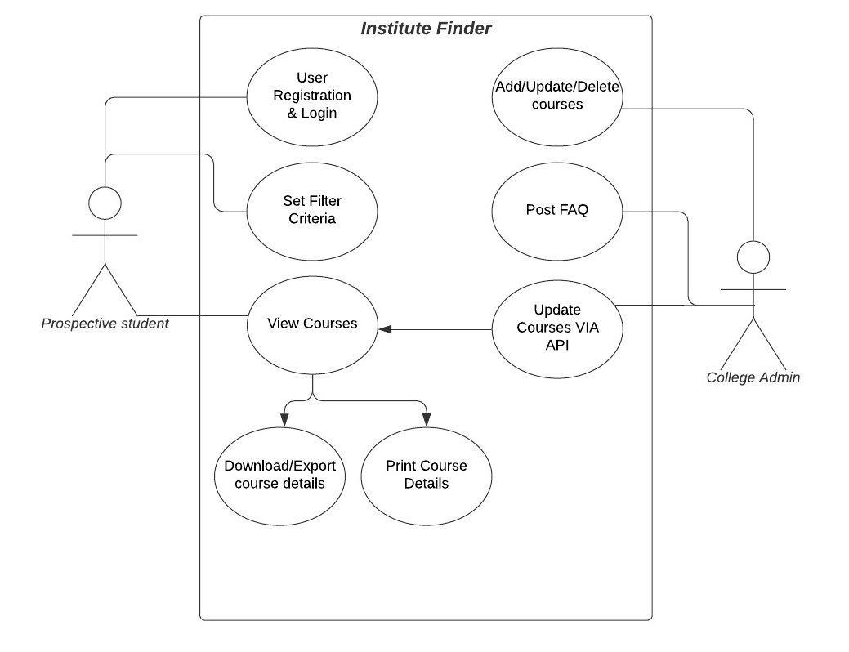

Institute Finder

Course Configuration

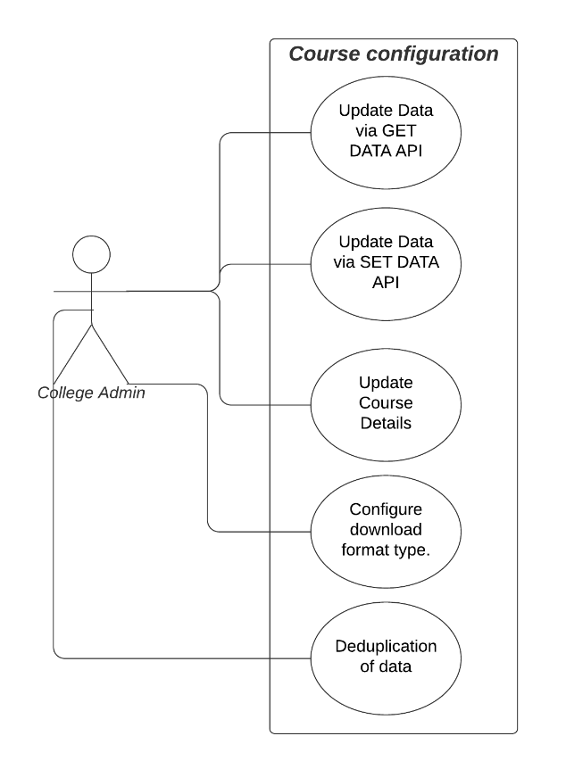

Course Configuration

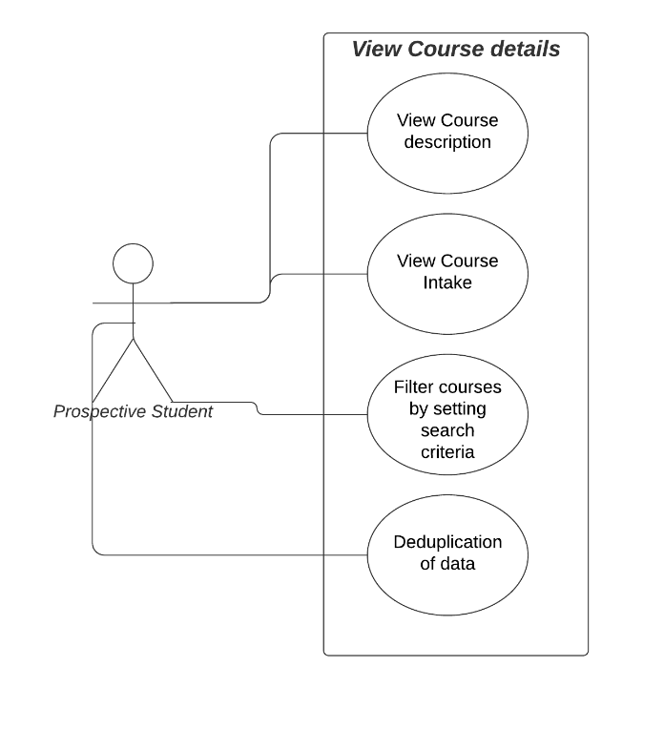

View Course Details

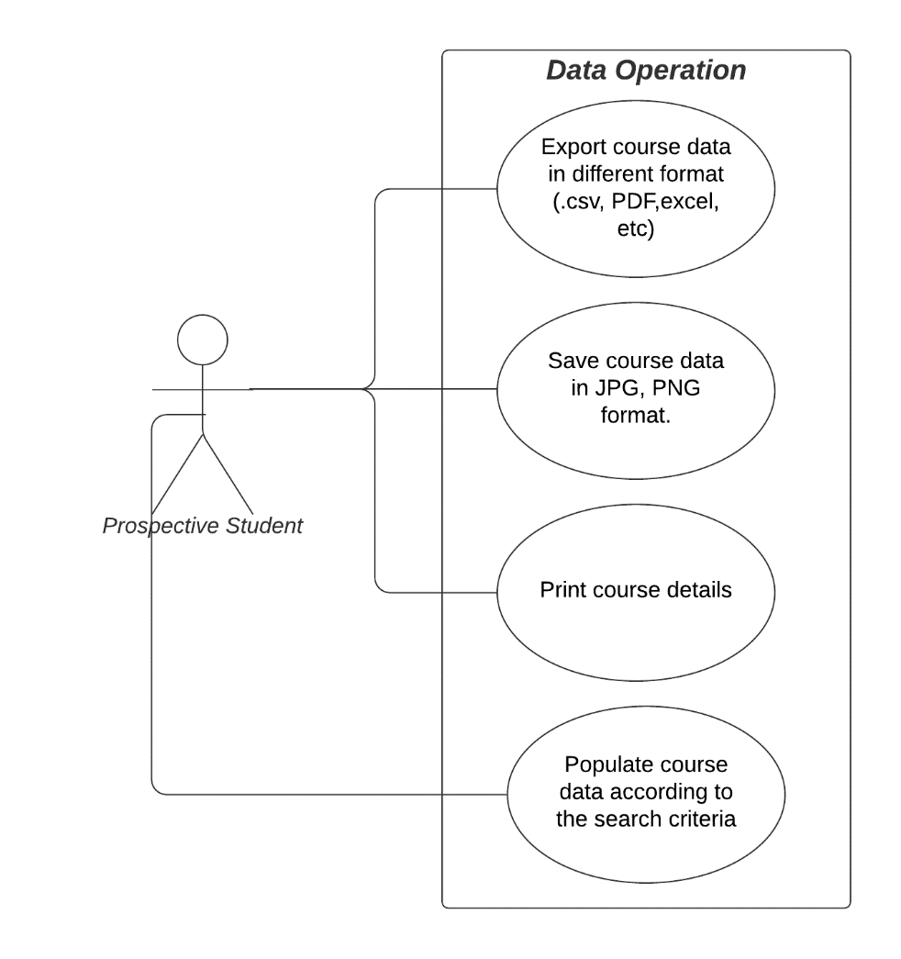

Data Operation

